SmartList allows you to easily create and save views of all your important master record data and provides real-time access to information in quick, easy queries that can be personalized and saved for future use. In addition, you can export information directly into Microsoft Word or Excel, eliminating extra steps and making you more productive.
With SmartList you can instantly create queries to find customer, vendor, general ledger account, inventory, employee and salesperson records. The familiar interface makes it easy to create lists and locate information from anywhere in your application. You can add, remove and rearrange columns the way you want.
Once you create a query, you can save it, print it, or share it with others. And queries can be imported into Microsoft Word or Excel with the click of a single button, making it a snap to update spreadsheets or create mailing lists for your sales and marketing efforts. Easy to learn and easy to use, the SmartList puts the power of information at your fingertips and helps you work smarter and faster.
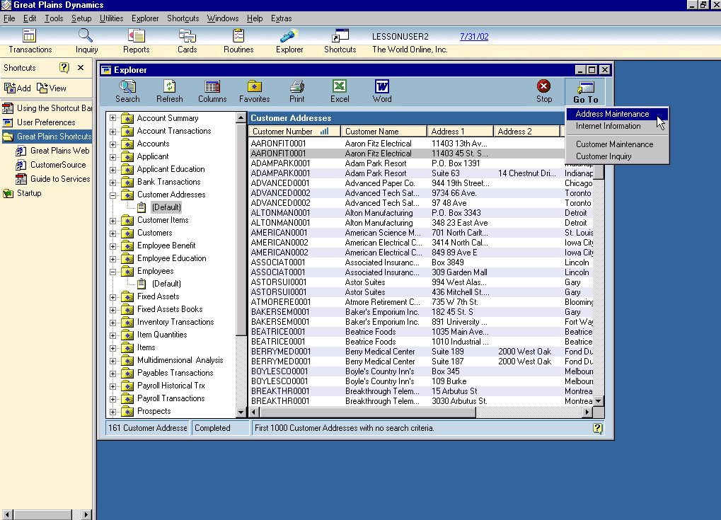
Instantly create queries to find customer, vendor, general ledger account, inventory, employee and salesperson records using SmartList.

SmartList highlights:
Available system-wide: Entering an order for a bicycle and need to find all cycling-related items? SmartList is at your fingertips, helping you pinpoint the exact information you’re looking for.
Lightning fast: SmartList retrieves the information you want with lightning speed and surgical precision. You’ll save time every time you use SmartList to build specialized inquiries.
Flexible: With SmartList you can sort customers by price level, vendors alphabetically with the telephone number as the second column—whatever’s important to you. You can review the information and instantly change the content or order of the query to match your needs.
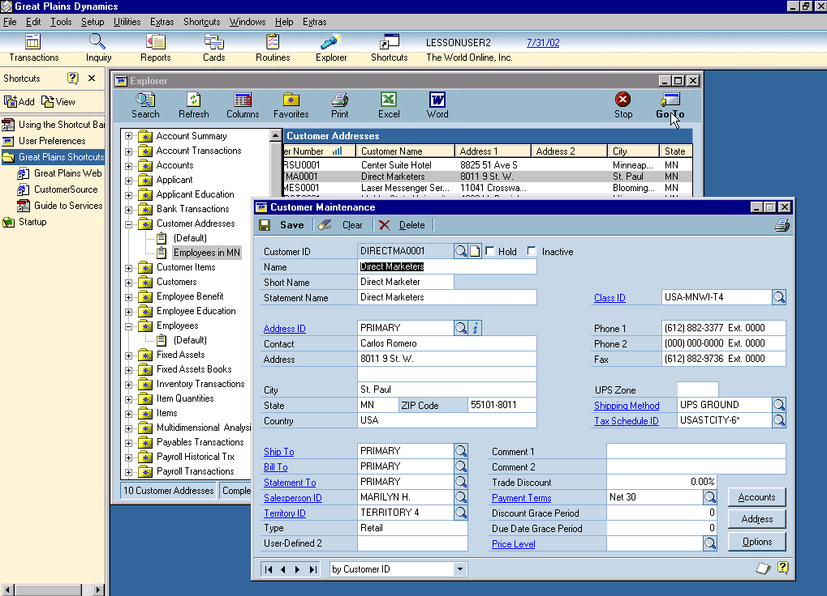
Go directly from SmartList to the corresponding module window by simply clicking on the Go To button all without ever leaving the SmartList window.

Easy access available system-wide
SmartList makes it easy to access information about:
- Customers and prospects
- Sales orders, sales transaction line items, and invoices
- Receivables documents
- Vendors and payables documents
- Purchase orders and purchase order line items
- Landed costs
- Inventory items and quantities
- Employees, applicants and payroll transactions
- Accounts, summaries and transactions
- Multidimensional Analysis codes
- Fixed Assets
Build and save your favorites: Select search criteria quickly with ‘Smart’ select functionality that helps you select the exact criteria you need to build your query. Then save queries as your favorites so you can quickly locate the specific information you need to do your job. These favorites can easily be refreshed so all new records will be instantly included in your query.
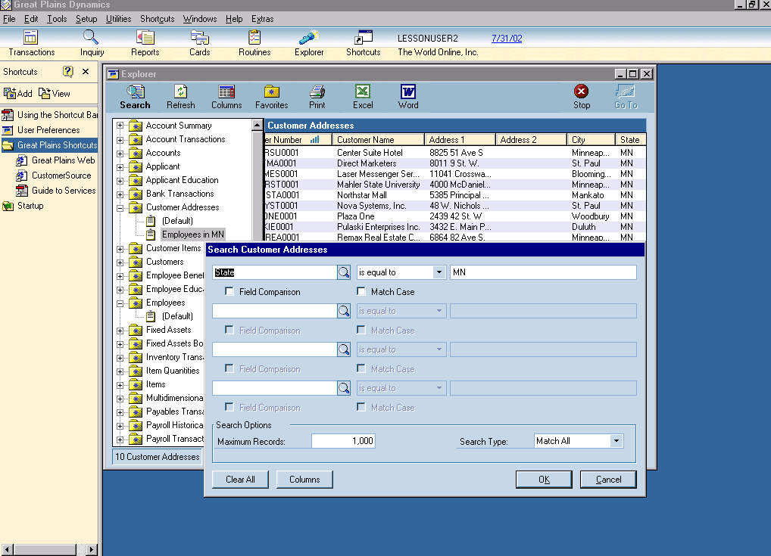
Create and define a query for your specific need, save it in your favorite’s folder and easily access it for future use.

Share the results: Increase team productivity by sharing queries with others. With SmartList, you can set security to make favorite views available to all companies, the company you are logged into, your user class or to you alone. In addition, the system administrator can grant or deny access to SmartList views to different users in the system on a per user or per class basis, ensuring your company’s employees will only be able to access the information you specify.
One click integration with Microsoft Word and Excel: Put the information from your system to work by importing inquiry results into Excel or Word with a simple click of a button. Use Word and Excel for mail merges, commission studies, and other critical business functions.
Use solution templates: Creating export solution templates are quick and easy. You can export information into Microsoft Word and Excel, eliminating extra steps and increasing productivity.
Compare data fields: You can compare data from two fields within SmartList to perform more sophisticated queries. In addition, you can search against data fields using “tokens” like today, yesterday, this week, last week, etc. instead of actual dates.
Resize the SmartList Window: Drag and drop the corners of the SmartList window so that it fits within your desktop the way you want it.

Here are some real-life ways SmartList can make your business more productive immediately:
- To target a mailing at all your customers in Wisconsin, use SmartList to create your list of Wisconsin customers. Import the information into Word with the click of a button, then use Word’s mail merge to send personalized letters to your customers. Use SmartList to save the list you created, and next month refresh the list to include all new Wisconsin customers you gained for your next mailing.
- If you typically work with several manufacturers, use the items view to find items available by manufacturer. Use SmartList to create and save queries for each manufacturer, making it easy to locate and reference the information you’re interested in, without searching through your entire inventory item by item.
- Find information quickly and accurately on your customer’s own terms, for example, use SmartList to search for sales transactions by customer purchase order number. Then drill down for sales transaction detail—all within a few seconds.
- With SmartList you can print mailing labels with barcodes for vendors, customers and more without sorting through lists of records. Just use the search option to define your range of contacts, then export directly into Microsoft Word to format and print your labels.
© 2002 Microsoft Corporation and Great Plains Software, Inc. All rights reserved. Microsoft, Microsoft Business Solutions and Great Plains are either registered trademarks or trademarks of Microsoft Corporation, Great Plains Software, Inc. or Microsoft Business Solutions Corporation in the United States and/or other countries. Both, Great Plains Software Inc. and Microsoft Business Solutions Corporation are wholly-owned subsidiaries of Microsoft Corporation. Functionality described herein may not be available on all versions of Microsoft Business Solutions–Great Plains products. The names of actual companies and products mentioned herein may be the trademarks of their respective owners.

